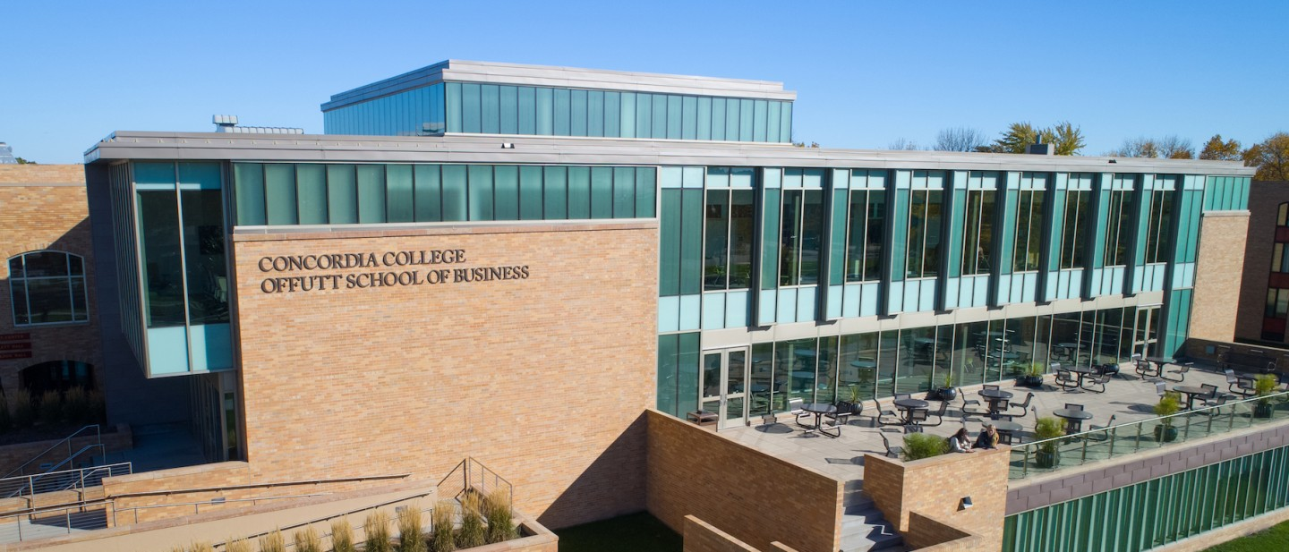

Project Proposal

|  |
| --- |
| Revolve Bank |

|  |  |
| --- | --- |
| Course | **CSC 225 – Fundamental Structures** |
|  | |
| Team Name | **Scattered Spider** |
|  |  |
| Team Members | **Devin Knecht** |
|  | **Lennox Magak** |
|  | **Amir Hosseini** |
|  | **Hien Nguyen** |

|  |
| --- |
| Executive Summary |
| **Your executive summary should resemble an elevator pitch: your motivation is to quickly persuade a decision maker to get involved in your project.** |
| * **What is the purpose of your project; what problem(s) does it address?** * **Why is your project important; why is it relevant? (NOTE: not in terms of the class to get a good grade)** * **Who could your project help; who is your audience or customer?** |
| Revolve Bank project aims to create a banking system that will revolutionize the traditional money and asset handling procedures. With Revolve banking system customers will enjoy **a more secure** and **trustworthy** banking. The system aims to ensure that only they (the customers themselves) and the individuals they authorize plus certain bank officials can access their accounts. This security approach aims to reduce incidences such as the Bangladesh Bank heist that occurred in 2016.  The new banking system aims to provide customers with **more organized and responsible management** of their things of value and personal information. Our ranks of staff from the Bank teller to the Branch manager will be issued with access and functionality limitations to ensure achievement of the desired responsibility and management in the system.  Our new banking system will not only enable customers to transact money between themselves, but we will also be able to help customers:   1. Easily liquidate their assets that they have stored/registered with us. 2. Easily buy assets from other customers on our platform, or from our own collection.   This **secure**, and **diversified approach** to banking, with more organized and responsible management, is relevant and important because it will:   1. bank the unbanked, asset saturated members of the society still involved in barter trade**.** 2. Encourage the already banked members of the society to move to our system due to the advanced security. 3. Provide customers with a binary platform that easily enables liquidation and/or acquisition of assets. 4. Provide customers with proper and more responsible management of their assets and capital, through our more organized accessibility hierarchy. |
|  |

|  |
| --- |
| Background and Problem History |
| * Explain the problem domain and relevant background information about your project * Provide a brief history of the problem; when did it start? What attempts have been made to solve it? * NOTE: Think in terms of your PROJECT, not in terms of this class |

|  |
| --- |
| Solution |
| * How does your team plan to solve the problem? * What makes your approach different from other solutions? |
| **Solution plan**  The Scattered Spider group, through our Revolve Bank initiative has come up with a solution-oriented system that will be developed to overcome most of the problems that we Identified with the traditional banking.  ***Problem 1: Poor Customer support***  To ensure an improved customer support system, the Revolve Bank development team, has focused on:   1. *Creating distinct ranks of authority*: These ranks have varying, distinct and increasing levels of access to functionality with regards to managing accounts:  * Level 1: The customers themselves. * Level 2: Bank tellers. * Level 3: Local Managers. * Level 4: Branch Managers   This way there will be a and well-informed management team with distinct roles thus improving the customer support system.  ***Problem 2: Excessive fees for basic services.***  Revolve Bank system will institutionalize low fees for the diverse services that we provide;  These fees will be decided later by the development team.  ***Problem 3: Long waiting time during customer service provision.***  To solve the long waiting whenever customers, want support from Bank personnel, the development team will supply/enhance the GUIs of each stakeholder type will all the functionalities endowed to their level. This way all stakeholders will quickly realize what exactly they can handle, and what they can’t. ???  ***Problem 4: Software systems that are not satisfactorily secure:***  Revolve bank development team aims to introduce multifactor authentication for all bank stakeholders from customers to the Branch manager, in addition to password difficult-to-guess user passwords.  **Problem 5: Criteria for awarding Loans.**  The development team will define clear criteria for giving out loans to customers. These criteria will include but not limited to:   1. The time they have duration they have banked with Revolve. 2. The total value of assets the own/store at Revolve. 3. The amount of loan they want.   **Problem 6: Diversification of dealings.**  Revolve banking software will be able to keep and maintain and avail records of the following upon authentic request:   1. Customer money. 2. Customer net worth. 3. Customer financial statements. 4. Customer loans 5. Accrued Interests etc. |

|  |
| --- |
| Project Deliverables |
| * What will be the “product” of your team’s project? What documents will you create? |
| 1. Revolve Bank will deliver a system interface with hierarchal access and functionality privileges for customers, bank tellers, local bank manager and branch manager.    1. Customer: Can call history of transfers, deposits, and withdrawals as well as the balance and transfer and deposit money. Receives interest and saves money. Limits on transactions and deposits.    2. Bank Teller: Can close and open customer accounts. Can assist a customer history of transfers, deposits, and withdrawals as well as the balance and transfer and deposit money. Can approve suspicious transactions. Suspicious deposits handled by a teller.    3. Local Bank Manager: Can act as and remove Bank Teller elements. Can also call customer statements with information to mail. For this bank the manager can understand the financial standing.    4. Branch Manager: Can invest money (with limits) and withdraw investments. Can create and destroy branches. Gets branch financial statements. Creates an overall report. Has control of time (when a quarter passes etc.). 2. Error messages that help tech support. This will help in saving time, by quickly letting customers and other stakeholders the Bank;    1. What exactly the error is.    2. How to better handle the error, or who amongst the stake holders can handle that specific error. 3. Revolve Bank will provide at least a two-factor authentication system to help enhance the security of customer money, and asset accounts.      * A hard-to-guess password. (followed by) * A secret word. (Could be a name of Customer’s secret pet)     Both the password and the secret word must match those entered by the customer during account creation for a successful login to happen.   1. Revolve Banking software will provide customers with a record of their financial and asset statements, and net worth.:    1. **Financial Statements**: This will entail dated entries of deposits, sent moneys, received money and moneys invested.    2. **Net worth**: Revolve bank will put together the total value of both customer’s finance and assets and display the current net-worth of the customer. 2. Revolve bank will enable customers to seamlessly convert and store their money in a maximum of 3 different currencies:    1. USD    2. Japanese Yen.    3. The Euro. |

|  |
| --- |
| Success Criteria |
| * How will your team define success? What aspects of your project can you quantify to objectively measure success? * NOTE: Think in terms of your PROJECT, not in terms of this class |
| **Scattered Spider Success Criteria.**  Team Scattered Spider will declare themselves successful in the Revolve Bank project of they:   1. Successfully create the following five bank stakeholder objects, each with their own stack of functionality: 2. Branch manager; Must be able to:  * Invest customer funds. * Withdraw investments. * Create and destroy Branches. * Generate Branch financial statements. * Create overall Bank report. * Define how long a quarter is.  1. Local Bank Manager:  * Act as Bank tellers. * Remove bank tellers. * Call customer Statements.  1. Bank Teller:  * Open customer accounts. * Close customer accounts. * Approve or deny customer deposits (Especially when larger than normal) * Approve or deny customer transactions (money sent or received especially when suspicious)  1. Customers:  * Deposit, transfer, and withdraw cash (when within the limits acceptable) * Deposit and liquidate other assets they own within Revolve Bank platform. * Request for Loans. * Pay back loans. * Request statements of both assets and money.  1. Successfully provide each customer with their financial statements , asset statements and net worth upon request. Normally at the click of a button. 2. Integrate an easy-to-understand error handling system that does exactly the following two activities: 3. Inform the stakeholder involved what exactly the error is. 4. Provide the stakeholder with directions on how to handle the error, or: 5. What level of authority, in the hierarchy mentioned in (1.) above, is authorized to handle the error. 6. Develop a seamless exchange platform where cusassettomers can exchange their currencies between any of the following three: 7. USD 8. Japanese Yen 9. The Euro. 10. Successfully develop a two-factor authentication system that uses both a password and secret word to enable all the stake holders login to their respective accounts. This will count as a success on the security aspect of the new software.   With the achievement of these SIX exact criteria, the new Revolve Bank System will be a success from our development perspective. |
|  |

|  |
| --- |
| List of Required Project Resources and Materials |
| * What resources (books, websites, data sets, problem domain information sources, software, etc.) will be / have been required to complete your project? |
| The following resources were used in helping us identify the problem in the current Banking system, definition of the problem scope and the development of the success criteria:  [Problems Faced by Customers in Banks: Challenges & Issues - GlobalBanks](https://globalbanks.com/problems-faced-by-customers-in-banks/#What)  [How strong are regional and community banks in the US? (usafacts.org)](https://usafacts.org/articles/how-strong-are-regional-and-community-banks-in-the-us/)  [5 Benefits Of Digital Banking – Forbes Advisor](https://www.forbes.com/advisor/banking/benefits-of-digital-banking/)  [Banking Software Development: Cost, Challenges, and Development Process - Matellio Inc](https://www.matellio.com/blog/banking-software-development-cost-challenges-development-process/#:~:text=1%20Banking%20software%20development%20has%20become%20a%20need,mobile%20banking%20capabilities%2C%20better%20conversions%2C%20etc.%20More%20items)  To complete the project the following software resources will be required:  1. Java Programming language.  2. Net Beans IDE.  3. Chat GPT Information Search Engine.  4. Web search Engine. Google and Microsoft Bing.  5. Get Hub. For proper coordination among team members. |